Incidence Conditions

Definition
# Source: AI Source: Provided by: [Data Path: Persons Table -> ID Column: 1, Name_En Column: Motasem Essam] -> From: [ChatGPT] on [7/25/2026]
Incidence Conditions are geometric conditions that specify whether geometric objects contain, pass through, intersect, or are connected to one another in a prescribed way.
The most basic incidence relationship is:
$$\boxed{P∈l}$$
which means that point $P$lies on line $l$.
Incidence does not primarily describe measurements such as length, angle, or area. Instead, it describes which geometric objects are related by belonging or passing through one another.
$$\boxed{\text{Incidence Condition}=\text{Requirement specifying a geometric containment or intersection relationship}}$$

Simple Definition
# Source: AI Source: Provided by: [Data Path: Persons Table -> ID Column: 1, Name_En Column: Motasem Essam] -> From: [ChatGPT] on [7/25/2026]
An Incidence Condition specifies whether a point, line, segment, plane, or other geometric object lies on, belongs to, passes through, or intersects another geometric object.
Examples
$$P∈l$$
Point $P$lies on line $l$.
$$A∈\overset{‾}{BC}$$
Point $A$lies on segment $BC$.
$$P∈\text{circle }C$$
Point $P$lies on the circle.
$$l_{1}∩l_{2}=P$$
Lines $l_{1}$and $l_{2}$intersect at $P$.

Main Types of Incidence Conditions
# Source: AI Source: Provided by: [Data Path: Persons Table -> ID Column: 1, Name_En Column: Motasem Essam] -> From: [ChatGPT] on [7/25/2026]
A practical classification is:
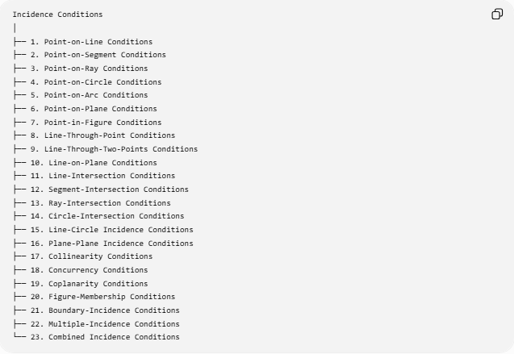
Incidence Conditions
│
├── 1. Point-on-Line Conditions
├── 2. Point-on-Segment Conditions
├── 3. Point-on-Ray Conditions
├── 4. Point-on-Circle Conditions
├── 5. Point-on-Arc Conditions
├── 6. Point-on-Plane Conditions
├── 7. Point-in-Figure Conditions
├── 8. Line-Through-Point Conditions
├── 9. Line-Through-Two-Points Conditions
├── 10. Line-on-Plane Conditions
├── 11. Line-Intersection Conditions
├── 12. Segment-Intersection Conditions
├── 13. Ray-Intersection Conditions
├── 14. Circle-Intersection Conditions
├── 15. Line-Circle Incidence Conditions
├── 16. Plane-Plane Incidence Conditions
├── 17. Collinearity Conditions
├── 18. Concurrency Conditions
├── 19. Coplanarity Conditions
├── 20. Figure-Membership Conditions
├── 21. Boundary-Incidence Conditions
├── 22. Multiple-Incidence Conditions
└── 23. Combined Incidence Conditions
This is a practical/descriptive classification. Some categories, such as collinearity and concurrency, are specialized forms of incidence.

1. Point-on-Line Conditions
# Source: AI Source: Provided by: [Data Path: Persons Table -> ID Column: 1, Name_En Column: Motasem Essam] -> From: [ChatGPT] on [7/25/2026]
Definition
A Point-on-Line Condition states that a point lies on a particular line.
$$\boxed{P∈l}$$
Example
If $P$lies on line $AB$:
$$\boxed{P∈\overset{↔}{AB}}$$
This means $A,P,B$are collinear.
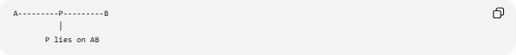
A---------P---------B
│
P lies on AB
Coordinate Example
For:
$$l:y=2x+1,$$
the point:
$$P=\left(3 , 7\right)$$
lies on $l$because:
$$7=2\left(3\right)+1.$$
Therefore:
$$\boxed{P∈l}.$$

2. Point-on-Segment Conditions
# Source: AI Source: Provided by: [Data Path: Persons Table -> ID Column: 1, Name_En Column: Motasem Essam] -> From: [ChatGPT] on [7/25/2026]
Definition
A Point-on-Segment Condition states that a point lies specifically on a finite line segment.
$$\boxed{P∈\overset{‾}{AB}}$$
This is stronger than merely saying that $P$lies on the line through $A$and $B$.
Example
A---------P---------B
Here:
$$\boxed{P∈\overset{‾}{AB}}.$$
Important Distinction
$$P∈\overset{↔}{AB}$$
allows $P$to be anywhere on the infinite line.
But:
$$P∈\overset{‾}{AB}$$
requires $P$to be between $A$and $B$, including endpoints when membership is allowed.

3. Point-on-Ray Conditions
# Source: AI Source: Provided by: [Data Path: Persons Table -> ID Column: 1, Name_En Column: Motasem Essam] -> From: [ChatGPT] on [7/25/2026]
Definition
A Point-on-Ray Condition states that a point lies on a ray beginning at a specified endpoint.
$$\boxed{P∈\vec{AB}}$$
Example
A---------B---------P-------->
Here:
$$\boxed{P∈\vec{AB}}.$$
The ray begins at $A$and passes through $B$.
Important Distinction
The three conditions:
$$P∈\overset{↔}{AB} \\ P∈\overset{‾}{AB} \\ P∈\vec{AB}$$
describe different allowable positions for $P$.

4. Point-on-Circle Conditions
# Source: AI Source: Provided by: [Data Path: Persons Table -> ID Column: 1, Name_En Column: Motasem Essam] -> From: [ChatGPT] on [7/25/2026]
Definition
A Point-on-Circle Condition states that a point belongs to the circumference of a circle.
If a circle has center $O$and radius $r$:
$$\boxed{P∈C}$$
is equivalent to:
$$\boxed{OP=r}.$$
Coordinate Form
For a circle centered at $\left(h , k\right)$:
$$\boxed{{\left(x-h\right)}^{2}+{\left(y-k\right)}^{2}=r^{2}}.$$
Example
For:
$$x^{2}+y^{2}=25,$$
the point:
$$P=\left(3 , 4\right)$$
lies on the circle because:
$$3^{2}+4^{2}=25.$$
Therefore:
$$\boxed{P∈C}.$$

5. Point-on-Arc Conditions
# Source: AI Source: Provided by: [Data Path: Persons Table -> ID Column: 1, Name_En Column: Motasem Essam] -> From: [ChatGPT] on [7/25/2026]
Definition
A Point-on-Arc Condition restricts circle membership to a particular arc.
$$\boxed{P∈\hat{AB}}$$
means $P$lies on the specified arc from $A$to $B$.
Example
If $P$is required to lie on the minor arc $AB$:
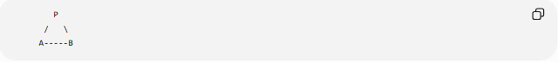
P
/ \
A-----B
then:
$$\boxed{P∈\hat{AB}}.$$
This is a restricted incidence condition because the point must lie on a particular portion of the circle.

6. Point-on-Plane Conditions
# Source: AI Source: Provided by: [Data Path: Persons Table -> ID Column: 1, Name_En Column: Motasem Essam] -> From: [ChatGPT] on [7/25/2026]
Definition
In three-dimensional geometry, a Point-on-Plane Condition states that a point belongs to a plane.
$$\boxed{P∈Π}$$
Coordinate Example
For plane:
$$2x+y-z=5,$$
point:
$$P=\left(1 , 2 , -1\right)$$
lies on the plane because:
$$2\left(1\right)+2-\left(-1\right)=5.$$
Thus:
$$\boxed{P∈Π}.$$

7. Point-in-Figure Conditions
# Source: AI Source: Provided by: [Data Path: Persons Table -> ID Column: 1, Name_En Column: Motasem Essam] -> From: [ChatGPT] on [7/25/2026]
Definition
A Point-in-Figure Condition specifies that a point belongs to the interior or region of a geometric figure.
For example:
$$\boxed{P∈△ABC}$$
can mean that $P$is inside the triangular region, depending on the convention being used.
More precisely, one can distinguish:
$$P∈int⁡\left(△ABC\right)$$
for the interior, and:
$$P∈∂\left(△ABC\right)$$
for the boundary.
Example
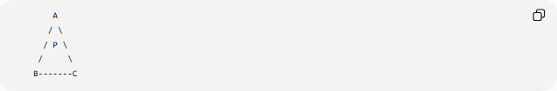
A
/ \
/ P \
/ \
B-------C
Here $P$is inside the triangle.

8. Line-Through-Point Conditions
# Source: AI Source: Provided by: [Data Path: Persons Table -> ID Column: 1, Name_En Column: Motasem Essam] -> From: [ChatGPT] on [7/25/2026]
Definition
A Line-Through-Point Condition requires a line to pass through a specified point.
$$\boxed{P∈l}$$
from the point's perspective, or:
$l$passes through $P$.
Example
Construct a line through $P$:
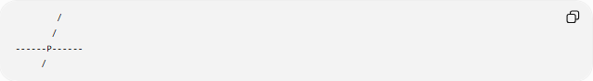
/
/
------P------
/
The condition is:
$$\boxed{P∈l}.$$
There are infinitely many lines through a single point in the Euclidean plane.
Additional conditions are usually required to determine a unique line.
For example:
$$P∈l$$
and:
$$Q∈l.$$
Then:
$$\boxed{l=\overset{↔}{PQ}}.$$

9. Line-Through-Two-Points Conditions
# Source: AI Source: Provided by: [Data Path: Persons Table -> ID Column: 1, Name_En Column: Motasem Essam] -> From: [ChatGPT] on [7/25/2026]
Definition
A Line-Through-Two-Points Condition requires one line to contain two specified points.
$$\boxed{A∈l, B∈l}$$
with $A≠B$.
By the Euclidean incidence postulate:
$$\boxed{\text{Exactly one line passes through two distinct points.}}$$
Therefore:
$$\boxed{l=\overset{↔}{AB}}.$$
This is one of the fundamental incidence relationships in Euclidean geometry.

10. Line-on-Plane Conditions
# Source: AI Source: Provided by: [Data Path: Persons Table -> ID Column: 1, Name_En Column: Motasem Essam] -> From: [ChatGPT] on [7/25/2026]
Definition
A Line-on-Plane Condition states that an entire line lies within a plane.
$$\boxed{l⊂Π}.$$
Example
If two distinct points $A$and $B$lie in plane $Π$:
$$A∈Π, B∈Π,$$
then the line through them lies in the plane:
$$\boxed{\overset{↔}{AB}⊂Π}.$$
This is an important point-line-plane incidence relationship.

11. Line-Intersection Conditions
# Source: AI Source: Provided by: [Data Path: Persons Table -> ID Column: 1, Name_En Column: Motasem Essam] -> From: [ChatGPT] on [7/25/2026]
Definition
A Line-Intersection Condition specifies that two lines share a common point.
$$\boxed{l_{1}∩l_{2}=P}.$$
Example
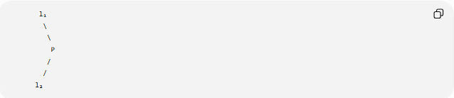
l₁
\
\
P
/
/
l₂
The lines intersect at $P$.
Therefore:
$$\boxed{P∈l_{1}}$$
and:
$$\boxed{P∈l_{2}}.$$
Important Cases
Two lines in a plane can be:
- intersecting → one common point
- parallel → no common point
- coincident → infinitely many common points.

12. Segment-Intersection Conditions
# Source: AI Source: Provided by: [Data Path: Persons Table -> ID Column: 1, Name_En Column: Motasem Essam] -> From: [ChatGPT] on [7/25/2026]
Definition
A Segment-Intersection Condition specifies that two finite segments have a common point.
$$\boxed{\overset{‾}{AB}∩\overset{‾}{CD}=P}.$$
Example
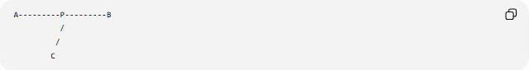
A---------P---------B
/
/
C
Here:
$$P∈\overset{‾}{AB}$$
and:
$$P∈\overset{‾}{CD}.$$
Therefore:
$$\boxed{P=\overset{‾}{AB}∩\overset{‾}{CD}}.$$
Important
Two segments can intersect even though their supporting lines are not identical.

13. Ray-Intersection Conditions
# Source: AI Source: Provided by: [Data Path: Persons Table -> ID Column: 1, Name_En Column: Motasem Essam] -> From: [ChatGPT] on [7/25/2026]
Two rays can have a common point.
$$\boxed{\vec{AB}∩\vec{CD}=P}$$
Example
Two rays may begin at different points and meet at $P$.
This type of condition is useful in geometric constructions and angle configurations.

14. Circle-Intersection Conditions
# Source: AI Source: Provided by: [Data Path: Persons Table -> ID Column: 1, Name_En Column: Motasem Essam] -> From: [ChatGPT] on [7/25/2026]
Definition
A Circle-Intersection Condition specifies that two circles have one or more common points.
$$\boxed{P∈C_{1}∩C_{2}}.$$
Possible Cases
Two distinct circles can have:
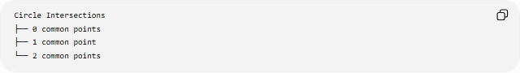
Circle Intersections
├── 0 common points
├── 1 common point
└── 2 common points
Example
Suppose:
$$C_{1}:C\left(A , 5\right)$$
and:
$$C_{2}:C\left(B , 5\right).$$
Their intersection points can be used to construct a perpendicular bisector or an equilateral triangle.

15. Line-Circle Incidence Conditions
# Source: AI Source: Provided by: [Data Path: Persons Table -> ID Column: 1, Name_En Column: Motasem Essam] -> From: [ChatGPT] on [7/25/2026]
Definition
A Line-Circle Incidence Condition specifies that a line and a circle share one or more points.
Cases
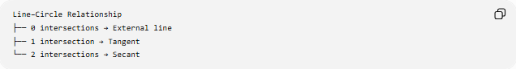
Line–Circle Relationship
├── 0 intersections → External line
├── 1 intersection → Tangent
└── 2 intersections → Secant
Tangency
If line $l$touches circle $C$at $T$:
$$\boxed{l∩C=\left\{T\right\}}.$$
Thus:
$$\boxed{T∈l}$$
and:
$$\boxed{T∈C}.$$
Secancy
If line $l$crosses the circle at $A$and $B$:
$$\boxed{l∩C=\left\{A , B\right\}}.$$

16. Plane-Plane Incidence Conditions
# Source: AI Source: Provided by: [Data Path: Persons Table -> ID Column: 1, Name_En Column: Motasem Essam] -> From: [ChatGPT] on [7/25/2026]
In three-dimensional geometry, two planes can intersect.
Intersecting Planes
If:
$$Π_{1}∩Π_{2}=l,$$
then their intersection is a line.
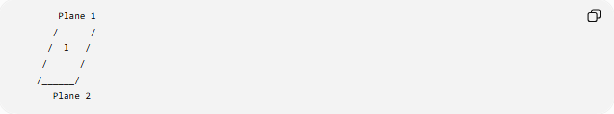
Plane 1
/ /
/ l /
/ /
/______/
Plane 2
Thus:
$$\boxed{\text{Two distinct intersecting planes meet in a line}.}$$
Parallel Planes
$$Π_{1}∥Π_{2}$$
have no common points.
Coincident Planes
If:
$$Π_{1}=Π_{2},$$
they share infinitely many points.

17. Collinearity Conditions
# Source: AI Source: Provided by: [Data Path: Persons Table -> ID Column: 1, Name_En Column: Motasem Essam] -> From: [ChatGPT] on [7/25/2026]
Definition
A Collinearity Condition states that several points lie on the same line.
For points $A,B,C$:
$$\boxed{A,B,C\text{ are collinear}}.$$
Equivalently:
$$\boxed{A,B,C∈l}$$
for some line $l$.
Example
A---------B---------C
All three points lie on the same line.
Coordinate Test
For:
$$A\left(x_{1} , y_{1}\right), B\left(x_{2} , y_{2}\right), C\left(x_{3} , y_{3}\right),$$
one test is:
$$\boxed{\left(x_{2}-x_{1}\right)\left(y_{3}-y_{1}\right)-\left(y_{2}-y_{1}\right)\left(x_{3}-x_{1}\right)=0}.$$
This is an incidence condition expressed algebraically.

18. Concurrency Conditions
# Source: AI Source: Provided by: [Data Path: Persons Table -> ID Column: 1, Name_En Column: Motasem Essam] -> From: [ChatGPT] on [7/25/2026]
Definition
A Concurrency Condition states that three or more lines pass through one common point.
$$\boxed{l_{1}∩l_{2}∩l_{3}=P}.$$
Example
The three medians of a triangle are concurrent at the centroid.
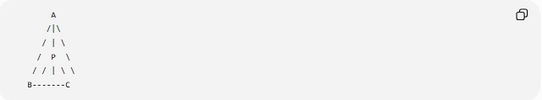
A
/|\
/ | \
/ P \
/ / | \ \
B-------C
Thus:
$$\boxed{\text{Three medians are concurrent}}.$$
Important Theorem
Ceva's Theorem provides a condition for three cevians of a triangle to be concurrent:
$$\boxed{\frac{BD}{DC}\frac{CE}{EA}\frac{AF}{FB}=1}$$
under the standard internal configuration.
Concurrency is therefore a specialized multi-line incidence condition.

19. Coplanarity Conditions
# Source: AI Source: Provided by: [Data Path: Persons Table -> ID Column: 1, Name_En Column: Motasem Essam] -> From: [ChatGPT] on [7/25/2026]
Definition
A Coplanarity Condition states that several points, lines, or objects lie in the same plane.
For points $A,B,C,D$:
$$\boxed{A,B,C,D\text{ are coplanar}}.$$
Example
Three non-collinear points always determine a plane.
If:
$$A,B,C∈Π,$$
then the plane determined by them is:
$$\boxed{Π=plane⁡\left(A , B , C\right)}.$$
A fourth point $D$is coplanar with them if:
$$\boxed{D∈Π}.$$

20. Figure-Membership Conditions
# Source: AI Source: Provided by: [Data Path: Persons Table -> ID Column: 1, Name_En Column: Motasem Essam] -> From: [ChatGPT] on [7/25/2026]
Definition
A Figure-Membership Condition specifies that an object belongs to a geometric figure or set.
Examples:
$$P∈△ABC \\ P∈C \\ P∈\overset{‾}{AB} \\ P∈\text{polygon }P_{1}P_{2}…P_{n}.$$
Membership is a broad form of incidence.

21. Boundary-Incidence Conditions
# Source: AI Source: Provided by: [Data Path: Persons Table -> ID Column: 1, Name_En Column: Motasem Essam] -> From: [ChatGPT] on [7/25/2026]
Definition
A Boundary-Incidence Condition requires an object to lie on the boundary of a region.
For a region $R$:
$$\boxed{P∈∂R}.$$
Example
For a disk:
- inside:
$$OP<r$$
- boundary:
$$OP=r$$
- outside:
$$OP>r.$$
Therefore:
$$\boxed{OP=r}$$
is both a distance equality and a boundary-incidence condition.

22. Multiple-Incidence Conditions
# Source: AI Source: Provided by: [Data Path: Persons Table -> ID Column: 1, Name_En Column: Motasem Essam] -> From: [ChatGPT] on [7/25/2026]
Definition
A Multiple-Incidence Condition requires an object to belong to several geometric objects simultaneously.
Example
$$\boxed{P∈l_{1}}$$
and:
$$\boxed{P∈l_{2}}.$$
Therefore:
$$\boxed{P∈l_{1}∩l_{2}}.$$
If $l_{1}$and $l_{2}$intersect at $P$, then:
$$\boxed{P=l_{1}∩l_{2}}.$$
Three Objects
$$\boxed{P∈C_{1}∩C_{2}∩l}.$$
The required point must simultaneously lie on two circles and one line.

23. Combined Incidence Conditions
# Source: AI Source: Provided by: [Data Path: Persons Table -> ID Column: 1, Name_En Column: Motasem Essam] -> From: [ChatGPT] on [7/25/2026]
Incidence conditions can be combined with other geometric conditions.
Example
Find $P$such that:
$$P∈\overset{‾}{AB}$$
and:
$$PA=5.$$
The first is an incidence condition.
The second is a length condition.
Together:
$$\boxed{P∈\overset{‾}{AB}∩C\left(A , 5\right)}.$$
The solutions are the intersection points of the segment with the circle.

Incidence Conditions and Loci
# Source: AI Source: Provided by: [Data Path: Persons Table -> ID Column: 1, Name_En Column: Motasem Essam] -> From: [ChatGPT] on [7/25/2026]
Incidence conditions are closely connected to loci.
Example
Condition:
$$P∈l.$$
The locus is simply:
$$\boxed{l}.$$
Another Example
Condition:
$$P∈C.$$
The locus is:
$$\boxed{C}.$$
Combined Example
$$P∈l$$
and:
$$PA=5.$$
Therefore:
$$P∈l∩C\left(A , 5\right).$$
Thus:
$$\boxed{\text{Incidence Conditions}→\text{Membership Loci}→\text{Intersections}}$$

Incidence Conditions in Geometric Proofs
# Source: AI Source: Provided by: [Data Path: Persons Table -> ID Column: 1, Name_En Column: Motasem Essam] -> From: [ChatGPT] on [7/25/2026]
Incidence statements are often used as givens.
Example
Given:
$$D∈\overset{‾}{BC}.$$
This tells us that $D$lies on segment $BC$.
Therefore:
$$\boxed{BD+DC=BC}.$$
So an incidence condition can lead to a length relationship.
Another Example
Given:
$$P∈\text{perpendicular bisector of }AB.$$
Then:
$$\boxed{PA=PB}.$$
Thus:
$$\text{Incidence Condition}→\text{Theorem}→\text{Equality Condition}.$$

Incidence and Other Geometric Conditions
# Source: AI Source: Provided by: [Data Path: Persons Table -> ID Column: 1, Name_En Column: Motasem Essam] -> From: [ChatGPT] on [7/25/2026]
Incidence conditions interact with many other condition types.
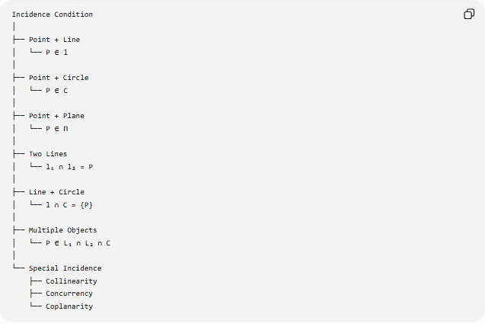
Incidence Condition
│
├── Point + Line
│ └── P ∈ l
│
├── Point + Circle
│ └── P ∈ C
│
├── Point + Plane
│ └── P ∈ Π
│
├── Two Lines
│ └── l₁ ∩ l₂ = P
│
├── Line + Circle
│ └── l ∩ C = {P}
│
├── Multiple Objects
│ └── P ∈ L₁ ∩ L₂ ∩ C
│
└── Special Incidence
├── Collinearity
├── Concurrency
└── Coplanarity

Incidence vs Intersection
# Source: AI Source: Provided by: [Data Path: Persons Table -> ID Column: 1, Name_En Column: Motasem Essam] -> From: [ChatGPT] on [7/25/2026]
These are related but different.
Incidence
$$P∈l$$
describes one object belonging to another.
Intersection
$$l_{1}∩l_{2}=P$$
describes the common part of two objects.
An intersection can be expressed through incidence:
$$P=l_{1}∩l_{2}$$
means:
$$P∈l_{1}$$
and:
$$P∈l_{2}.$$
Therefore:
$$\boxed{\text{Intersection}=\text{Common Incidence}}$$
in this basic setting.

Incidence vs Distance
# Source: AI Source: Provided by: [Data Path: Persons Table -> ID Column: 1, Name_En Column: Motasem Essam] -> From: [ChatGPT] on [7/25/2026]
These conditions are fundamentally different.
Incidence
$$P∈l$$
says $P$lies exactly on $l$.
Distance
$$d\left(P , l\right)=5$$
says $P$is 5 units away from $l$.
If:
$$P∈l,$$
then:
$$\boxed{d\left(P , l\right)=0}.$$
Therefore, incidence can sometimes be expressed as a zero-distance condition, but the concepts have different geometric meanings.

Coordinate Representation of Incidence
# Source: AI Source: Provided by: [Data Path: Persons Table -> ID Column: 1, Name_En Column: Motasem Essam] -> From: [ChatGPT] on [7/25/2026]
Many incidence conditions can be converted into equations.
Point on Line
For:
$$ax+by+c=0,$$
a point:
$$P=\left(x_{0} , y_{0}\right)$$
is incident with the line if:
$$\boxed{ax_{0}+by_{0}+c=0}.$$
Point on Circle
For:
$${\left(x-h\right)}^{2}+{\left(y-k\right)}^{2}=r^{2},$$
point $P=\left(x_{0} , y_{0}\right)$is incident with the circle if:
$$\boxed{{\left(x_{0}-h\right)}^{2}+{\left(y_{0}-k\right)}^{2}=r^{2}}.$$
Point on Plane
For:
$$ax+by+cz=d,$$
point $P=\left(x_{0} , y_{0} , z_{0}\right)$lies on the plane if:
$$\boxed{ax_{0}+by_{0}+cz_{0}=d}.$$

Important Incidence Principles
# Source: AI Source: Provided by: [Data Path: Persons Table -> ID Column: 1, Name_En Column: Motasem Essam] -> From: [ChatGPT] on [7/25/2026]
Several fundamental Euclidean principles are incidence statements.
Two Points Determine a Line
For distinct $A,B$:
$$\boxed{∃! l: A∈l, B∈l}.$$
There is exactly one line through two distinct points.
Three Non-Collinear Points Determine a Plane
If $A,B,C$are non-collinear:
$$\boxed{∃! Π: A,B,C∈Π}.$$
Two Intersecting Lines Determine a Plane
If two distinct lines intersect:
$$l_{1}∩l_{2}=P,$$
then they lie in a common plane.
Two Distinct Planes Intersect in a Line
If two planes are not parallel and not identical:
$$\boxed{Π_{1}∩Π_{2}=l}.$$

Classification Summary
# Source: AI Source: Provided by: [Data Path: Persons Table -> ID Column: 1, Name_En Column: Motasem Essam] -> From: [ChatGPT] on [7/25/2026]
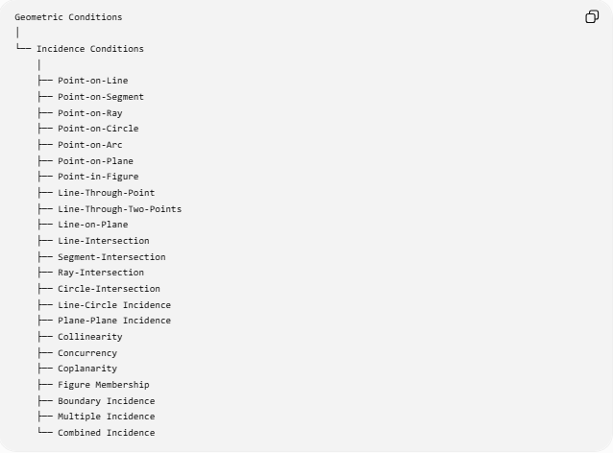
Geometric Conditions
│
└── Incidence Conditions
│
├── Point-on-Line
├── Point-on-Segment
├── Point-on-Ray
├── Point-on-Circle
├── Point-on-Arc
├── Point-on-Plane
├── Point-in-Figure
├── Line-Through-Point
├── Line-Through-Two-Points
├── Line-on-Plane
├── Line-Intersection
├── Segment-Intersection
├── Ray-Intersection
├── Circle-Intersection
├── Line-Circle Incidence
├── Plane-Plane Incidence
├── Collinearity
├── Concurrency
├── Coplanarity
├── Figure Membership
├── Boundary Incidence
├── Multiple Incidence
└── Combined Incidence

Key Formulas and Notation
# Source: AI Source: Provided by: [Data Path: Persons Table -> ID Column: 1, Name_En Column: Motasem Essam] -> From: [ChatGPT] on [7/25/2026]
Point on line
$$\boxed{P∈l}$$
Point on segment
$$\boxed{P∈\overset{‾}{AB}}$$
Point on ray
$$\boxed{P∈\vec{AB}}$$
Point on circle
$$\boxed{P∈C}$$
or:
$$\boxed{OP=r}.$$
Point on plane
$$\boxed{P∈Π}$$
Line intersection
$$\boxed{l_{1}∩l_{2}=P}$$
Circle intersection
$$\boxed{P∈C_{1}∩C_{2}}$$
Collinearity
$$\boxed{A,B,C\text{ are collinear}}$$
Concurrency
$$\boxed{l_{1}∩l_{2}∩l_{3}=P}$$
Coplanarity
$$\boxed{A,B,C,D∈Π}$$
Point-line coordinate incidence
$$\boxed{ax_{0}+by_{0}+c=0}$$
Point-circle coordinate incidence
$$\boxed{{\left(x_{0}-h\right)}^{2}+{\left(y_{0}-k\right)}^{2}=r^{2}}$$

Key Points
# Source: AI Source: Provided by: [Data Path: Persons Table -> ID Column: 1, Name_En Column: Motasem Essam] -> From: [ChatGPT] on [7/25/2026]
- Incidence Conditions describe geometric relationships based on belonging, lying on, passing through, or intersecting.
- The fundamental notation is:
$$\boxed{P∈l}.$$
- A point can be incident with:
  - a line,
  - segment,
  - ray,
  - circle,
  - arc,
  - plane,
  - geometric region.
- Two points determine a unique line.
- Three non-collinear points determine a unique plane.
- Intersections are naturally expressed through common incidence.
- Collinearity is a multiple point-line incidence condition.
- Concurrency is a multiple line-point incidence condition.
- Coplanarity is a multiple point-plane incidence condition.
- Incidence conditions can be converted into coordinate equations.
- Incidence conditions frequently combine with length, angle, equality, and distance conditions.
- Incidence is closely connected with loci and geometric constructions.
- Incidence itself does not primarily describe measurement; it describes geometric membership or connection.

Conclusion
# Source: AI Source: Provided by: [Data Path: Persons Table -> ID Column: 1, Name_En Column: Motasem Essam] -> From: [ChatGPT] on [7/25/2026]
Incidence Conditions specify how geometric objects are positioned relative to one another through containment, membership, passage, or intersection.
The fundamental structure is:
$$\boxed{\text{Incidence Condition}→\text{Geometric Membership or Intersection}→\text{Geometric Configuration}}$$
For example:
$$\boxed{P∈l→\text{P lies on line }l} \\ \boxed{P∈C→\text{P lies on circle }C} \\ \boxed{l_{1}∩l_{2}=P→\text{P is the common point of }l_{1}\text{ and }l_{2}} \\ \boxed{A,B,C\text{ collinear}→\text{A,B,C lie on one line}} \\ \boxed{l_{1},l_{2},l_{3}\text{ concurrent}→\text{all three lines pass through one point}}$$
Thus, incidence conditions form a foundational layer of geometry, connecting points, lines, segments, rays, circles, planes, intersections, collinearity, concurrency, coplanarity, loci, constructions, and geometric proofs.

